

BOILING POINT & MIXTURES

JOAKIM HERTZBERG

ALEKSANDRA PANKAU, YASH CHHATBAR

TABLE OF CONTENTS

1: INTRODUCTION 1

1.1: BACKGROUND 1

1.1.1: THEORY 1

1.2: QUESTION & AIM 1

1.3: HYPOTHESIS 2

2: METHOD 2

3: RESULTS 2

4: DISCUSSION 2

4.1: ANALYSIS 2

4.2: CONCLUSION 2

4.3: EVALUATION 2

5: SOURCES 2

# 

# 1: INTRODUCTION

## 1.1: BACKGROUND

Intermolecular forces (IMFs) have throughout the history of chemistry regularly been observed in various molecular substances. Afformentioned forces can be observed in everything from the cup of coffee you may have drunk this morning to the fuel that propels your vehicle.

In this laboration the effect that these forces have on the boiling points of mixtures will be observed as the IMFs change.

The boiling point is the temperature at which a certain substance and/or mixture transforms into its gaseus form.

An Intermolecular Force is an attraction between molecules (*inter*- *[prefix]* being latin for *between*1)

The compounds used in the laboration will exclusively be *organic compounds2.*

## 1.2: THEORY

To interpret the results from this lab, it is essential to understand the underlying variables affecting them. The most profound variable that should be understood is Intermolecular Forces. Although there exists a wide array of intermolecular forces there are certain variations that are more of essence to this laboration.

A dipole-dipole attraction is an attraction between two polar molecules acting as dipoles in a magnetic field. An induced/temporary dipole attraction on the other hand exists between a polar molecule and a non-polar one, the negative and positive poles on the dipole attract and repell the electrons around the atoms existing in the polar molecule, this causes the molecules to more commonly exist on one end of the non-polar, temporarily making it a dipole.

The last two major types of molecular interactions are hydrogen bonds. Although these are technically not bonds, but an intermolecular attraction, they are most often called bonds. These “bonds” occur when an oxygen, nitrogen, or florine and a hydrogen that is covalently bonded to an oxygen, nitrogen, or florine attract eachother.

The last, and weakest intermolecular force that is relevant is wandervaals attraction, which is quite similar to an induced dipole, except with all non-polar molecules. Since electrons orbit around atoms, a non-polar molecule will be in a constant state och changing polarity, essentially analogous to a rotating dipole.

|  |  |  |
| --- | --- | --- |
| **Tbl. 1** Properties of the chemical used in the laboration | | |
| Chemical | Boiling Point (℃) | Polarity |
|  | 78 | Polar |
|  | 98 | Non-polar |
|  | 77 | Polar |
| (acetone) | 56 | Polar |
|  | 97 | Polar |
|  | 82 | Polar |

## 1.3: QUESTION & AIM

Determining how mixing different organic compounds affect the boiling point of a mixture.

# 2: METHOD

The reflux condenser was set up as per *Fig. 1*. The water was turned on and allowed to run through the condenser, the heating mantle was then turned on with medium heat set. 10cm3 of the solvent was measured up and added to the top of the reflux condenser. The temperature of the pure liquid was measured as it begun to boil. 2 cm3 of the solute was added and the temperature of the new solution’s boiling point was recorded. This procedure was then repeated until the total volume of solute reached 10cm3. The heat was turned off and the apparatus was allowed to cool. The process was then repeated with the solute and solvent swapped. This entire process was repeated for all three sets of liquids.

**Fig. 1** Reflux Condenser

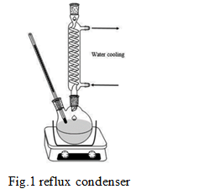

# 3: RESULTS

**Fig. 2** Boiling point of the mixture relative to the proportion of heptane & ethanol

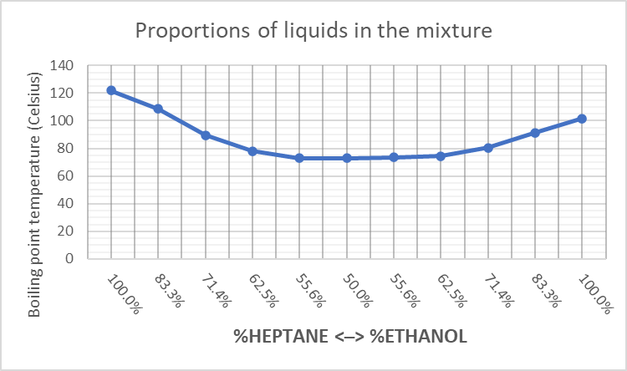

# 

**Fig. 3** Boiling point of the mixture relative to the proportion of propan-2-ol & propan-1-ol

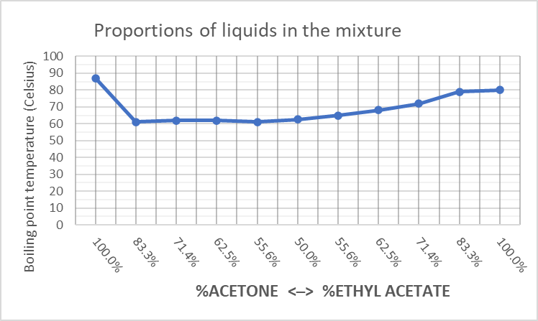

**Fig. 4** Boiling point of the mixture relative to the proportion of acetone & ethyl acetate

|  |  |  |
| --- | --- | --- |
| **Tbl. 2** Boiling point in relation to proportion of heptane and ethanol in the mixture | | |
| % heptane | Boiling point | % ethanol |
| 0.00% | 122 | 100.0% |
| 16.67% | 108.5 | 83.3% |
| 28.57% | 89.5 | 71.4% |
| 37.50% | 78 | 62.5% |
| 44.44% | 73 | 55.6% |
| 50.00% | 72.875 | 50.0% |
| 55.56% | 73.5 | 55.6% |
| 62.50% | 74.5 | 62.5% |
| 71.43% | 80.5 | 71.4% |
| 83.33% | 91.5 | 83.3% |
| 100.00% | 101.5 | 100.0% |

|  |  |  |
| --- | --- | --- |
| **Tbl. 3** Boiling point in relation to proportion of propan-1-ol and propan-2-ol in the mixture | | |
| % propan-1-ol | Boiling point | % propan-2-ol |
| 0.00% | 112 | 100.00% |
| 16.67% | 114.5 | 83.33% |
| 28.57% | 107 | 71.43% |
| 37.50% | 98 | 62.50% |
| 44.44% | 93 | 55.56% |
| 50.00% | 89.75 | 50.00% |
| 55.56% | 90.25 | 44.44% |
| 62.50% | 91.5 | 37.50% |
| 71.43% | 96.5 | 28.57% |
| 83.33% | 98.5 | 16.67% |
| 100.00% | 75 | 0.00% |

|  |  |  |
| --- | --- | --- |
| **Tab. 4** Boiling point in relation to proportion of ethyl acetate and acetone in the mixture | | |
| % ethyl acetate | Boiling point | % acetone |
| 0.00% | 87 | 100.00% |
| 16.67% | 61 | 83.33% |
| 28.57% | 62 | 71.43% |
| 37.50% | 62 | 62.50% |
| 44.44% | 61 | 55.56% |
| 50.00% | 62.5 | 50.00% |
| 55.56% | 65 | 44.44% |
| 62.50% | 68 | 37.50% |
| 71.43% | 72 | 28.57% |
| 83.33% | 79 | 16.67% |
| 100.00% | 80 | 0.00% |

# 4: DISCUSSION

## 4.1: RESULT ANALYSIS

*Fig. 2* shows a curve similar to an exponentially decaying regression from the 50% mark on the curve, and then turning around to what seems like an exponentially growing regression. *Fig. 3* shows an initial spike and what then seems to be a linearly decaying regression. *Fig. 4* hand shows an instant dip in boiling point from the pure solution to 83.3% acetone and then a seemingly positive linear regression.

## 4.2: RESULTS DISCUSSION

### 4.2.1: HEPTANE & ETHANOL

For the first trials, containing ethanol and heptane, this trial shows a “banana-shaped” curve, decaying from the pure solution until the midpoint at 50% and then turning back up again. This could be due to the fact that ethanol is capable of hydrogen bonding, while heptane is not.

**Fig. 5** Ethanol Hydrogen-bonding2

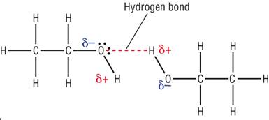

## 

From the onset, the solution was pure heptane, having a boiling point of 120°C due to its mass and Wandervaals attraction. As ethanol got added to the solution, induced dipole forces start occurring and a minute amount of ethanol begins to hydrogen bond. Although hydrogen bonds and induced dipole attractions are stronger than the Wandervaals attraction that existed earlier, these intermolecular forces are not strong enough to compensate for the general density decrease in the solution, hence the decrease in boiling point. As the solution approaches the 50/50-point on the graph, the intermolecular forces get strong enough to compensate more and more for the general mass decrease. When it reaches the 50% point on the graph, the hydrogen bonds between ethanol molecules get strong enough to compensate for the density decay, causing the boiling point to rise again until it reaches the boiling point at 100% ethanol.

### 4.2.2: PROPAN-1-OL & PROPAN-2-OL

*Fig. 3* shows a linearly decreasing regression with an initial spike, since both liquids have the same molecular mass, that can immediately be ruled out as a factor in this trial. Henceforth, the change in values must be caused by a change in intermolecular forces. This insinuates that the intermolecular forces decreased as propan-1-ol was added to the solution, meaning propan-1-ol is not capable of as strong intermolecular forces as propan-2-ol. However, this trend is inconsistent with the boiling points of propan-2-ol and propan-1-ol. Therefore, this data is deemed inaccurate.

### 4.2.3: ACETONE & ETHYL ACETATE

*Fig. 4* shows a linearly increasing regression, apart from the first data point, being 30℃ higher than the value after. Due to this extreme dip in temperature as well as the deviation from the previously recorded boiling point of acetone, it is reasonable to deem said data point as a fluke. Looking at the rest of the data points, a linearly increasing regression is represented. Since both acetone and ethyl acetate are only capable of dipole-dipole attractions, although acetone has a higher relative polarity, polarity cannot be responsible for this increase as that would directly contradict the collected data. Therefore, the increase in temperature of the boiling point could be due to the increase in molar mass as ethyl acetate was added. Since ethyl acetate has a higher molar mass than acetone, it would have a higher boiling point. This is consistent with the linear increase in boiling point as the amount of ethyl acetate increases.

## 4.3: EVALUATION

This laboration showed a great amount of values inconsistent with the previously collected data. This could be due to:

Inconsistent temperature measurement – Using a graduated thermometer causes a certain margin of error since the temperature is determined by the human eye, a more consequent method of temperature measurement would be instruments that are more precise, such as a digital thermometer.

Damaged/ incorrectly utilised equipment – The reflux condenser utilised in the laboration was a piece of equipment unfamiliar to the laborants performing the experiment. Thus it may have been assembled incorrectly or misused. Another possibility is that the equipment was damaged before the laboration.

Suboptimal control variables - The laboration utilized one control valuable – volume – if mass had been used to measure the liquids instead, it could have been completely eliminated. If it was, it would have been possible to get a more conclusive answer.

# 5: SOURCES

1 *Nationalencyklopedin*. “inter-“, <http://www.ne.se/uppslagsverk/encyklopedi/lång/inter->, 2023-01-16.

2[https://www.google.com/url?sa=i&url=https%3A%2F%2Fwww.toppr.com%2Fask%2Fquestion%2Fhydrogen-bonding-is-maximum-in-2%2F&psig=AOvVaw32aYvnWy31ss1Axvl2DCFP&ust=1674322869631000&source=images&cd=vfe&ved=0CBAQjRxqFwoTCICl2_DY1vwCFQAAAAAdAAAAABAW](https://www.google.com/url?sa=i&url=https%3A%2F%2Fwww.toppr.com%2Fask%2Fquestion%2Fhydrogen-bonding-is-maximum-in-2%2F&psig=AOvVaw32aYvnWy31ss1Axvl2DCFP&ust=1674322869631000&source=images&cd=vfe&ved=0CBAQjRxqFwoTCICl2_DY1vwCFQAAAAAdAAAAABAW,), 2023-01-20.